
MINI PROJECT:
REVIEW -01 REPORT
PROJECT TITLE: GESTURE BASED VOLUME CONTROL BY USING
MACHINE LEARNING
STUDENTS AND ROLL NUMBER:
1.K.Nandan : 23CSE3016
2.M.Adithya : 23CSE3003
3.T.Rithwik : 23CSE3007
4.G.Manoj : 23CSE3014
5.MD.Abdur rehaman : 23CSE3047

BRANCH: Computer Science Engineering.
BATCH NO: 2023-2027
SEMESTER: 3rd year, 6th semester.

GUIDE: Prof.Maheh Babu.

DEPARTMENT/INSTITUTE: Chaitanya Deemed to be University.
ACADEMIC YEAR: 2025-2026
ABSTRACT:
The aim of this project is to develop a gesture-based volume control system using Python programming language and several libraries, including OpenCV, Mediapipe, PyCaw and NumPy. The system is designed to allow users to adjust the volume of their computer by making hand gestures in front of a camera. The project uses Mediapipe, a machine learning framework, to detect and track the user's hand movements and recognize specific gestures thatcorrespond to volume adjustments. OpenCV is used for camera input and image processing, allowing the systemto capture and analyze the user's hand movements in real-time. NumPy is used for data manipulation and processing, while PyCaw provides a Python interface to the Windows CoreAudio API, allowing the system to interact with the computer's audio system. The system consists of three main components: hand detection and tracking, gesture recognition, and volume control. Hand detection and tracking are implemented using Mediapipe's hand tracking module, which detects the user's hand and provides a set of landmarks representing the hand's position and orientation Gesture recognition is implemented using a simple machine learning algorithm that classifies the user's hand gestures based on the positions of the hand landmarks. Finally, volume control is implemented using PyCaw to adjust the system's audio volume based on thedetected hand gestures. The project provides an intuitive and efficient wayfor users to adjust their computer's audio volume without the need for a physical input device. It also demonstrates the potential of machine learning and computer vision technologies for developing novel andinteractive user interfaces. This mini-project report outlines the development of a gesture-based volume control system utilizing machine learning. Traditional methods of volume adjustment rely on physical interfaces like knobs, buttons, or touchscreens. This project introduces a more intuitive, touchless interaction method by using a standard webcam to capture and interpret hand gestures in real-time.
The system employs computer vision techniques to detect and track hand movements. Machine learning algorithms, such as Convolutional Neural Networks (CNNs) or techniques using libraries like MediaPipe, are trained to recognize specific gestures, for example, a closed fist for mute, a thumbs-up for increasing volume, or a horizontal movement of an open hand to incrementally adjust the level [1].
The core objective is to create a responsive and user-friendly interface. The methodology involves data collection for training the model, pre-processing the video input, extracting key features, and classifying the gestures. The output of the machine learning model is then mapped to the operating system's audio control interface, enabling seamless interaction.
The result is a low-cost, effective solution for hands-free volume management, demonstrating practical applications of machine learning in creating more natural human-computer interaction (HCI) experiences. The project highlights the potential of gesture recognition technology to enhance accessibility and convenience in everyday computing environments

PROBLEM DEFINITION:
"To develop a robust and intuitive system that utilizes a webcam and machine learning algorithms (such as computer vision and hand tracking) to interpret specific hand gestures in real-time, translating those gestures into corresponding volume control commands for a computer's audio output."
This system should address the limitations of traditional physical interfaces by providing a touch-less, accessible, and interactive method for adjusting audio levels.

EXISTING SYSTEM AND DRAWBACK
Classical interactions tools like keyboard, mouse, touchscreen and etc., may limit the way we use the system. All these systems require physical contact, in order to interact with system. Gestures can interpret same functionality without physically interacting with the interfacing devices.
NEED OF PROPOSED SYSTEM
Our proposed system aims on providing the service with no physical contact and only with the gesture action. In the all existing system about volume gesture control is providing the volume control service using only with the any one of thephysical contacts like arm band, remote and etc. In Our project we did not use any other physical contacts to controls the volume. At first the user has to using the capture module. In thismodule is responsible for capturing video from the user's camera. It will use OpenCV to access the camera andretrieve frames from it. After that Handdetection module. In this This modulewill use the Mediapipe library to detectthe user's hand in each frame. It will analyze the hand landmarks detected by Mediapipe to determine theposition of the hand. After that Gesturerecognition module will analyze theposition of the hand detected by the hand detection module to determine ifthe user is making a volume gesture. Itwill use NumPy to perform mathematical operations on the hand landmarks data. Then Volume control module will use the Mediapipe libraryto detect the user's hand in each frame.It will analyze the hand landmarks detected by Mediapipe to determinethe position of the hand.
OBJECTIVES
- To design a touchless volume control system using hand gestures to improve user convenience and accessibility.
- To apply machine learning techniques for recognizing and interpreting real-time hand gestures captured through a camera.
- To reduce dependency on physical input devices like keyboards, mice, or remote controls for volume adjustment.
- To implement real-time gesture detection using computer vision and image processing techniques.
- To map specific hand gestures (such as finger distance or hand movement) to volume increase and decrease actions.
- To enhance human–computer interaction (HCI) by enabling natural and intuitive gesture-based control.
- To ensure accuracy and responsiveness of the system under different lighting conditions and hand positions.
- To develop a low-cost and scalable solution that can be implemented using a standard webcam without special hardware.
- To gain practical experience in machine learning, computer vision, and real-time application development.
- To demonstrate the feasibility of gesture-based control systems for smart devices and future applications.

LITERATURE SURVEY
A non-local algorithm for hand gestures was proposed by A. Buades, B. Coll, and J. Morel. At the moment, finding finger movement algorithms remains a valid task. Functional analysis and statistics collide. Despite the fact that most recently presented approaches have a high level of sophistication, Algorithms have not yet reached a satisfactory degree of performance applicability. All work admirably when the model matches the algorithm assumptions, but they all fail in general, producing defects in analyzing the pixels through the camera. The primary goal of this study is to define a generic mathematical and experimental technique for comparing and classifying conventional hand movement recognition algorithms. For the no required elements in the video frame, Golam Moktader Daiyan et al. (2012) suggested a high performance decision based median filter. This technique detects noise pixels iteratively over numerous phases before replacing them with the median value. Noise detection is accomplished by enlarging the field of view. Mask till 77% to keep the extraction of local data going. Furthermore, if the algorithm fails to find a noise-free pixel at 7 7, the processing pixel is replaced by the last processed pixel. If the noise-free median value isn't available in the 7th processing window, the last processed pixel is used to determine if it is noise-free. The method chooses a window size if the last processed pixel is noisy. Calculate the number of 0s and 255s in the processing window using the 1515 dimension. Then, in the selected window, replace the processed pixel with 0 or 255, whichever is higher in number. Rajeshwari Kumar Dewangan et.al accurate object information and obtain a location using a deep learning object recognition technique. Object recognition algorithms are designed based on the Single Shot Multi Box Detector (SSD) structure, an object recognition deep learning model, to detect objects using a camera. H. Jabnoun et, al suggested the system that restores a central function of the visual system which is the identification of surrounding objects which is based on the local features extraction concept. Using SFIT algorithm and keypoints matching showed good accuracy for detecting objects. Košale U, Žnidaršic P, Stopar K suggested that Detection of obstacles is performed by Time of Flight (ToF) sensors, whose ranging data is then processed with an on-board microcontroller and send via Bluetooth connection to the belt. The belt is equipped with a second microcontroller, which interprets the data and presents it to the wearer with 15 vibration motors arranged in a square grid. The glasses are worn on the head, whereas the belt is attached around the stomach area. But the number of sensors detecting the obstacle decreased with the distance. Circle and square were detected better than triangle. This project aims to lower the communication gap between the deaf or mute community and the normal world. This project was meant to be a prototype to check the feasibility of recognizing sign language using sensor gloves. With this project the deaf or mute people can use the gloves to perform sign language and it will be converted in to speech so that normal people can easily understand. The main feature of this project is Gesture Volume Control that the gesture recognizer is a standalone system.

PROPOSED SYSTEM/SOLUTION
The purpose of this project is to control system volume using hand gestures without touching any physical device. It uses machine learning and computer vision to detect hand movements through a webcam. The system improves user convenience and provides a natural way of human–computer interaction. It also demonstrates the real-time application of gesture recognition technology.
Overcoming the Existing Problems of the System
- Removes the need for physical devices by allowing touchless volume control using hand gestures.
- Provides faster and more convenient control compared to manual volume adjustment.
- Improves accessibility and user interaction through natural and intuitive gestures.
- Reduces hardware dependency and cost by using a simple webcam instead of special sensors.

SYSTEM ARCHITECTURE/DESIGN
- Input Device (Webcam)
  - Captures real-time video frames of the user’s hand gestures.
- Frame Acquisition & Preprocessing
  - Video is divided into frames.
  - Frames are resized, converted to suitable color format, and noise is reduced for better detection.
- Hand Detection & Tracking
  - Computer vision techniques (e.g., OpenCV, MediaPipe) detect the hand and track finger positions.
- Feature Extraction
  - Important features like finger landmarks or distance between fingers are extracted from the hand image.
- Machine Learning Model
  - The ML model interprets the extracted features to recognize the gesture (increase/decrease volume).
- Gesture Interpretation Logic
  - Maps recognized gestures to volume control commands.
- System Volume Control Module
  - Adjusts the system volume in real time based on the gesture output.
- Output (Audio Volume Change)
  - The system volume increases or decreases instantly according to hand movement.

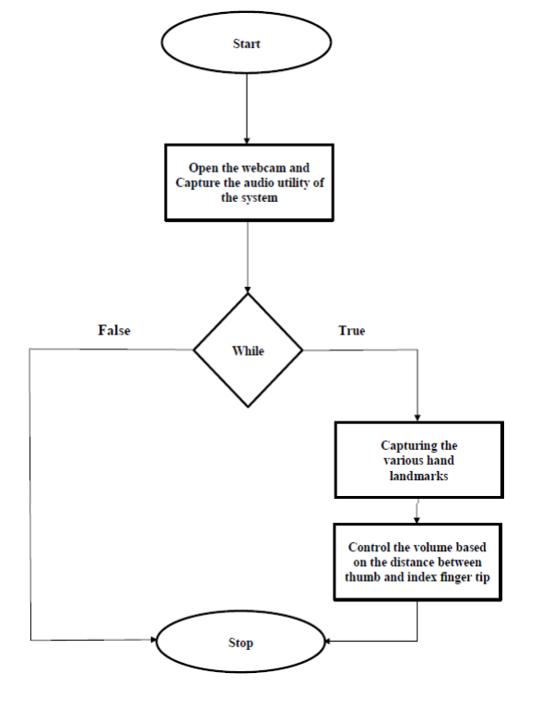

MODULE-WISE DESCRIPTION
1. Input Module (Webcam Module)
- Captures real-time video of the user’s hand using a webcam.
- Continuously sends video frames to the system for processing.
- Acts as the primary input source for gesture detection.

2. Frame Processing Module
- Converts the live video stream into individual frames.
- Performs image preprocessing such as resizing, color conversion, and noise reduction.
- Improves image quality for accurate hand detection.

3. Hand Detection & Tracking Module
- Detects the presence of a hand in each frame.
- Tracks hand movement and finger positions in real time.
- Uses computer vision techniques to isolate the hand region from the background.

4. Feature Extraction Module
- Extracts key features such as finger landmarks or distance between fingers.
- Converts hand gestures into numerical data.
- Provides meaningful input to the machine learning model.

5. Machine Learning Gesture Recognition Module
- Analyzes extracted features using a trained ML model.
- Identifies the type of gesture (e.g., increase or decrease volume).
- Ensures accurate and real-time gesture recognition.

6. Gesture Interpretation Module
- Maps recognized gestures to specific actions.
- Example:
  - Fingers apart → Volume Up
  - Fingers close → Volume Down
- Acts as a bridge between gesture recognition and system control.

7. Volume Control Module
- Sends commands to the operating system.
- Adjusts system volume smoothly based on gesture input.
- Works in real time without delay.

8. Output Module
- Displays volume level changes visually (optional).
- Produces immediate audio feedback by changing system volume.
- Confirms successful gesture execution.

TOOLS AND TECHNOLOGIES
- Language: Python
- Libraries: OpenCV, MediaPipe, NumPy, PyCaw
- Hardware: Webcam, Laptop
- IDE: VS Code / PyCharm
- Technology: Machine Learning, Computer Vision.

FEASIBILITY
The project is technically feasible using Python, OpenCV, and a standard webcam.
It is economically feasible as it requires no additional hardware and uses free, open-source tools.
The system is easy to use and can be completed within the given academic time frame.
CONCLUSION
The Gesture-Based Volume Control using Machine Learning project successfully demonstrates a touchless and intuitive method for controlling system volume using hand gestures. By integrating computer vision and machine learning techniques, the system accurately detects hand movements in real time and converts them into volume control commands using a standard webcam.
This project reduces dependency on physical input devices, improves human–computer interaction, and provides a cost-effective and accessible solution. It also offers valuable practical experience in machine learning, image processing, and real-time application development, highlighting the potential of gesture-based interfaces for future smart and interactive systems.

REFERENCE
- R.ALAMI ''A Methodological approach relating the classification of gesture to identification of human intent in the context of human-robot interaction", 371-377 2005.
- PERALES "Hand tracking and gesture recognition for human- computer interaction",2005.
- G.R.S. Murthy, R.S. Jadon. "A Review of vision based Hand Gestures Recognition," International Journal of Information Technology and Knowledge Management, vol.2(2),pp.405410, 2009.
- R.Liang and M. Ouhyoung. A Real-time continuous Gesture Recognition System for Sign Language. Proc. FG, 1998.
- https://www.taylorfrancis.com/chapters/edit/10.1201/9781003534112-9/volume-controller-using-hand-gestures-anup-lal-yadav-prabhneet-singh

